<https://github.com/mamido/New-Website-1> / Username: - mamido / Mohammad Nofal

[https://github.com/Idris 183/New-Website-1](https://github.com/Idris%20183/New-Website-1) / Username: - Idris 183 / Idriss Mohamed

* team names:-
* Mohammad Nofal / x14113112
* Idriss Mohamed / x14110792
* A short description of who did what work
* We worked as a team. Mohammad did first 2 pages – homepage and classes page as well as the website design and page with images too.
* Idriss did 2 pages- about and contact as well as helping with website design.
* A short description of the site and your client interaction
* My client is an artist/designer. The website is an advertisement of his work as he also offers lessons. There are videos, pictures and descriptions of how to draw.
* He drove us mad in the process of getting the website ready as I’m still waiting for some images and descriptions to finish off the page, but all is good- we are learning how to deal with difficult clients.
* Our Wireframes:-
* HOME PAGE.

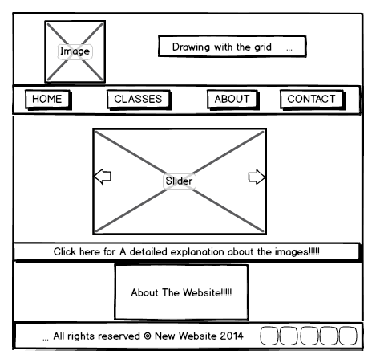

* CLASSES PAGE

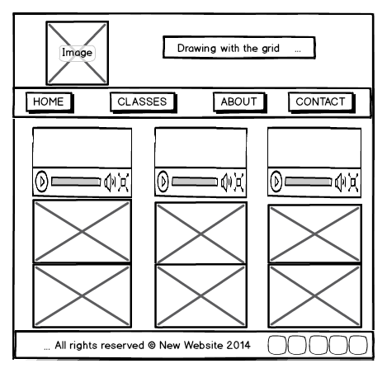

* ABOUT PAGE

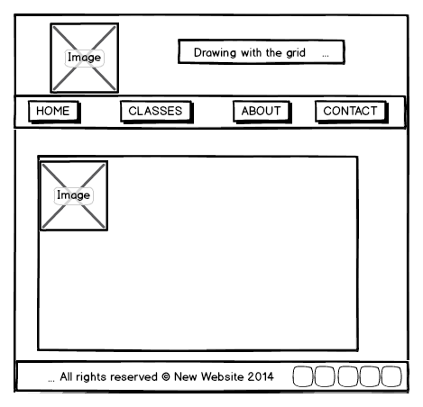

* CONTACT PAGE

